**Name: Riya Jacey Kurian**

**Roll No:29**

**Batch:S2 MCA**

**Date:24/04/22**

**NETWORKING&SYSTEM ADMINISTRATION LAB**

**Experiment No.: 7**

**Aim**

**Familiarization of basic linux commands**

**Procedure:**

**1.read**– used to store the content of a line to a variable

**syntax:**

**$**read name

$ echo $name

**output:**

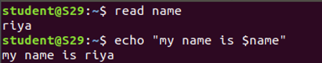

**2. locate**-used to locate a particular file or directory and displaying the path also.

**Syntax:**

$locate a.txt

**output:**





3. **find** – used to only the filename display with a particular directory

**syntax:**

find doc1.txt

**output :**



4.**df**– used to get a report of system disk space usage

**syntax:**

**$**df

**output:**

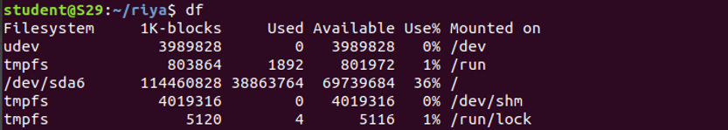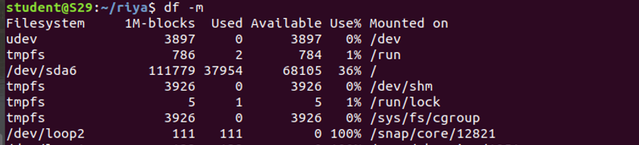

**5.du –** to check how much space a curreent directory or file which takes

Syntax:

$du

**Output:**



**6.wc**- used for counting purpose .it is used to find the number of lines ,the no of words,the no of characters and the no of bytes

$ wc -l doc1.txt

$wc -w doc1.txt

$wc -c doc1.txt

$wc – m doc1.txt

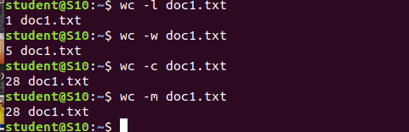output

**7. grep -** used to let you search through all the text in a given file .to search particular word in a file

Syntax :

$grep hello doc1.txt

$grep -A1 hello doc1.txt

$grep -i hello doc1.txt

output

